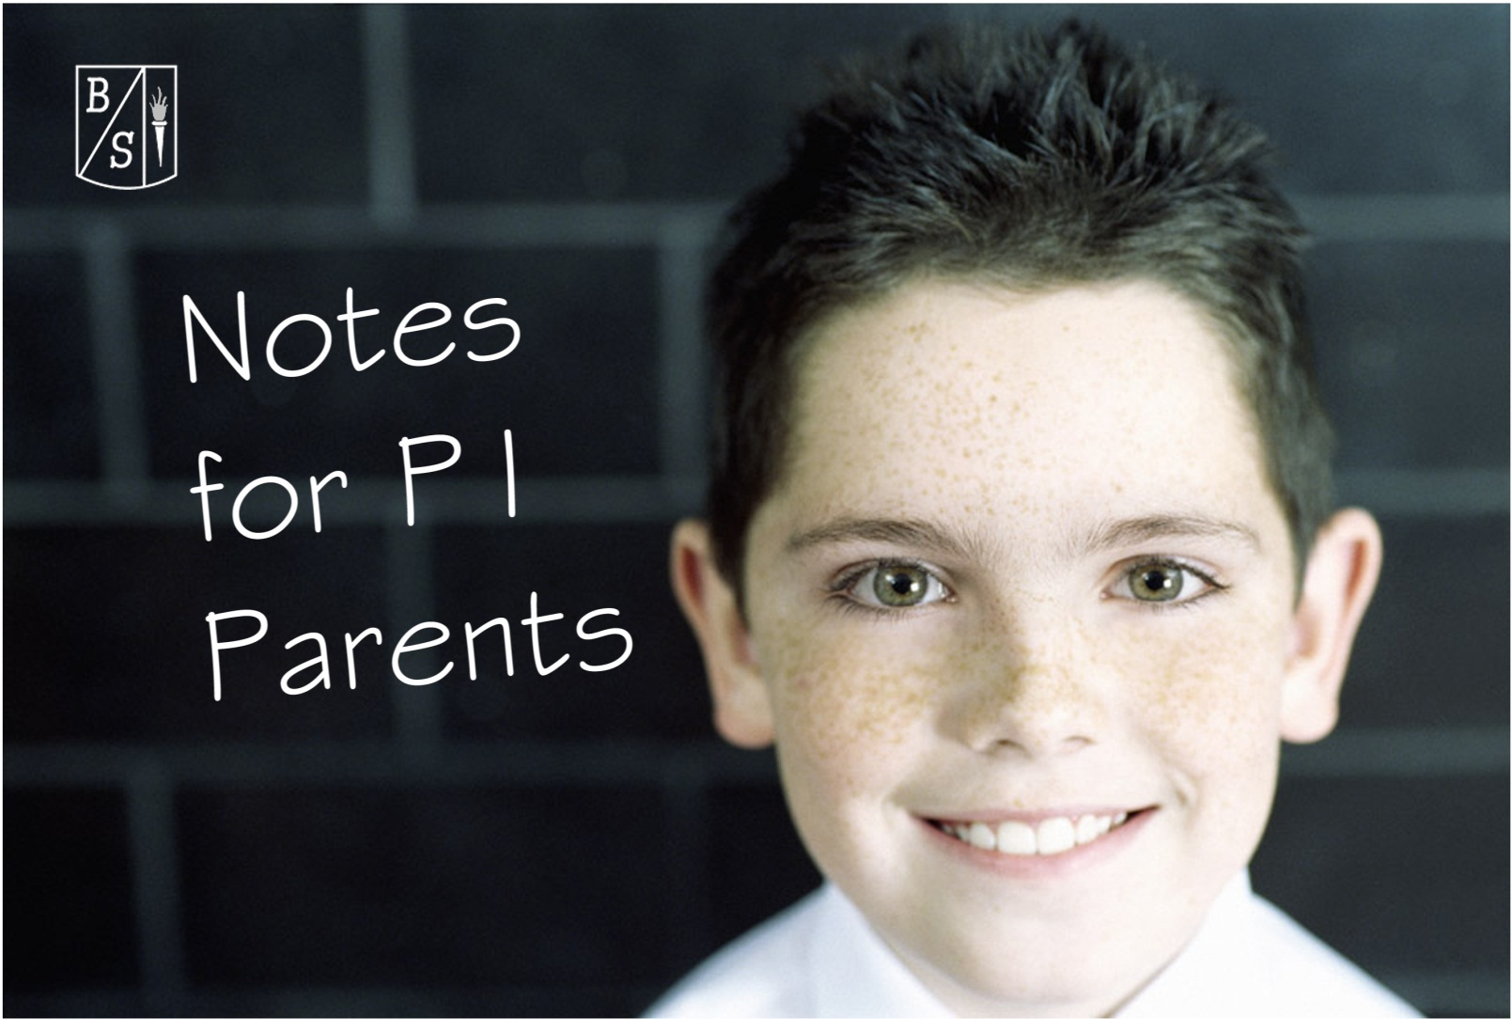

School Times:
Pr 1’s start school at 8.45am
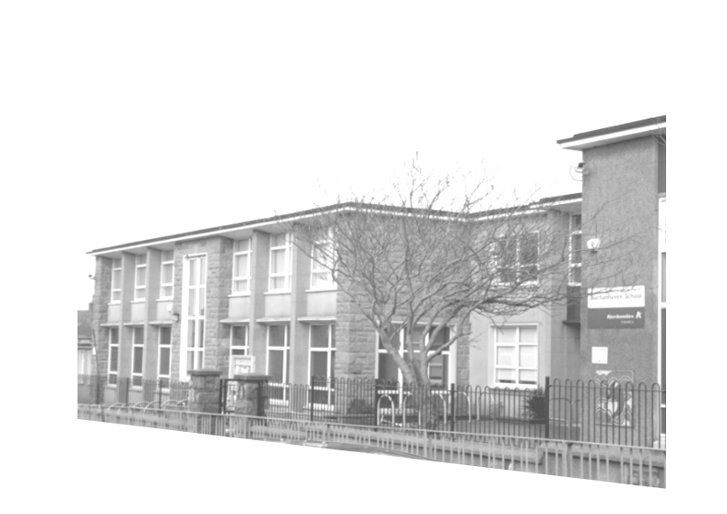
Lunch is 12 noon – 1pm
School ends at 3pm

School Uniform
Boys: Grey/black school trousers, green or white polo shirt, green sweatshirt/tank top, white shirt, school tie, suitable footwear.
Girls: Grey/black school skirt/kilt/trousers, green or white polo shirt, green sweatshirt/cardigan, white blouse, school tie, suitable footwear.
Outdoor shoes will be worn in the class; unless it is wet/snowing when they will need shoes to change into. (These can be the shoes that are in their PE bags).
Please ensure that your child has a waterproof jacket with them each day as you cannot predict the weather! It is essential that all clothing be clearly marked with your child’s name and class so it can be returned if misplaced.
School Supplies Needed
Ensure that your child has a bag big enough to hold the homework pack shown at this meeting. PE Kit – t-shirt, shorts and gym shoes and also outdoor kit (jogging trousers & sweatshirt) clearly marked with your child’s name. These stay in school. Please also mark their name on their gym bag. NO FOOTBALL KITS allowed. Painting Apron – Please provide your child with a painting apron or an old shirt for art. Pens / Pencils – these are supplied by the school.
Homework
Your child will receive a reading record and this will detail their homework each night. Please initial each night. This book should be used as a method of communication with the teacher. If you require to speak to your child’s teacher, please contact them through the main office.
Healthy Tuck
The following are available: Apple juice (25p) orange juice (25p) fruit (20p) biscuit (20p).
*please note these prices are subject to change*

Water
Your child is welcome to bring a water bottle into the class each day, but please note NO JUICE or FLAVOURED WATER. Please ensure your child’s name is on their water bottle.

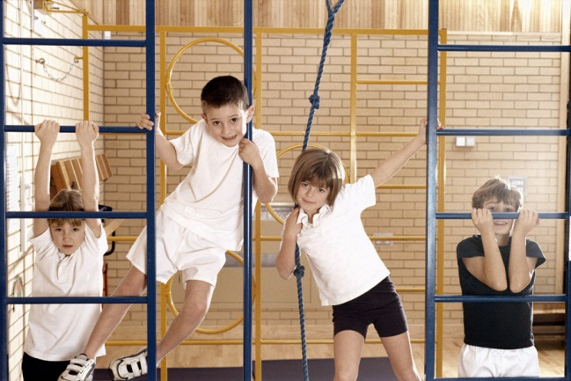
Gym
Your child will have PE twice a week.
At the start of each term you will receive a note with the day your child has PE. Please ensure that your child has their PE kit with them when they start so it can be left at school. Long hair needs to be tied back and if your child has earrings please either remove them on this day or supply tape to cover them. The PE kits will be sent home at the end of each term to be washed and they should return to school with your child when school restarts.
Break time
Break will be sometime between 10.30a.m. & 11.00a.m.
The children will go outside for play even if there is slight rain. If the weather is too wet, the children visit the toilet then have activities / games in the class. Pr 7 pupils and PSA’s monitor at this time.

Lunches
School dinners – all of our school dinners are now purchased through the online system iPayimpact and you will be provided with the code you require to set this up. School dinners for Pr 1-3 are free but from Pr 4 onwards they will be charged as below: Purchasing Dinners - A school dinner costs £2.50 and can be bought using the iPayimpact system. You can upload money to your account online at www.ipayimpact.co.uk. Your child can then purchase the meal of their choice once they arrive in class. Only water will be served with dinners
Your child will be supervised by staff and PSA’s at lunchtime.
Packed Lunches – your child will eat their packed lunch in the main hall and are also supervised at this time.
Home Dinners – Your child can be picked up from the gate they enter through in the morning at 12 noon and should be returned to their playground for school starting again at 1pm. On rainy days, your child should enter through the main doors on their return to school.
*Please Note – your child will not be rushed through their lunch, they can take as long as they need to eat*
Parent and Child Lunch – You will be invited to come and join your child and experience a School Dinner with them.
Your Child’s First Day – you will receive information explaining which day your child will start school and the time they start school on that day. This will tell you which door your child will enter through and where you, as a parent, can stand. The School does not allow parents into the playground whilst the children are there unless you have permission. This is to ensure that the teachers can see all the pupils. As a parent you will be invited to accompany your child to their classroom for a short time to help them settle in.
Parent and child activities
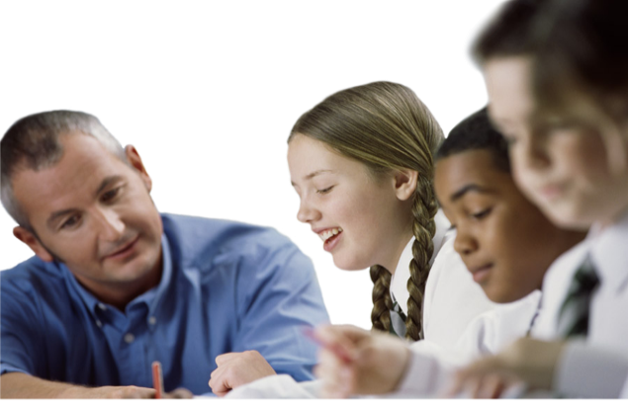
Meet the Teacher – You will be invited to come into School and meet your child’s teacher and also see their classroom, peg etc.
Absence
On the first day of sickness please advise the school as close to 9am as possible of your child’s absence. There will be someone at the School from 8.30am to take your call. If your son/daughter has sickness/diarrhoea they must be kept at home for 48 hours from the last time they were sick/diarrhoea.
Parking
Please adhere to the parking restrictions around the school and, if possible, park a little away from the school and walk the short distance to school.
Childsmile
Childsmile ladies visit the school throughout the year to chat to the pupils regarding dental health and reinforce the need to keep their teeth healthy. They also do Fluoride Varnishing (applying a paste) to your child’s teeth but this will not be done without your permission.
Medication
Any medication that your child is required to take during the School day will require a permission form to be completed and signed by the parent. Please go to the office to complete the form and then the medication can be left in school. The medication should be clearly marked with your child’s name, class, dosage and in a clear bag.
Should your child require the use of an asthma inhaler again a form requires to be completed. The inhaler should be clearly marked with child’s name, class, dosage and placed in a clear bag – this will then be kept in their schoolbag/class tray or on their person so it is easily accessible should it be required. It is advisable to have a spare inhaler in school at all times.

Please note that inhalers must accompany the pupils on outdoor activities or school trips.
School Nurse
At times a nurse will come to School from the Academy to take part in screening checks. If your child is involved in any meeting with the Nurse you will be notified. Nothing will be done if we do not have your permission.
Transport
We do not have a School Bus to take your child to School. It is your responsibility to ensure your child gets to and from School.

Crossing Patrol
Should your child walk to school, there are a number of Crossing Patrollers around the school. The main ones are: Balmoor Terrace, Blackhouse Terrace, Ugie Street/Skelton Street and the Fraserburgh roundabout.

Houses
When your child starts Primary one, they will be allocated a "House" and issued with a "House" badge which they should wear on a daily basis to school. We have four houses at the School: Balmoor, Craigewan, Ugie and Waterside. Siblings will be allocated to the same "House".
Pupils vote in the election of their House Captains and Vice Captains. Pupils earn points for their house by adhering to the school behaviour policy etc and the points are counted each week. The "House" with the most points over the month wins a "House Treat". Pupils suggest ideas for these and their wishes are accommodated as much as possible. At the end of the year the "House" with the most points accumulated over the year wins the "Burnett House Cup".

Over the year there are inter-house competitions which encourage pupils to work as a team across all ages and stages within the school.
School Management Team
Head Teacher: Mrs Linda Strachan
Depute Head Teachers:
Mrs E Stephen
Mrs L McAleese
Mrs L Norris (Acting) Miss K Falconer
(Acting) Miss S Alexander

Administrators: Mrs Lynne Strachan
Mrs Marion Ritchie

Clerical/Reception: Mrs Grace Grugeon

