Buchanhaven School Ready to Learn Checklist
Children have a calm morning routine.
 | Parents will… | Pupils will… | Staff will…
 | - Ask staff about the opportunity to join breakfast club if they feel this is something that would benefit their child/children. | Have eaten breakfast | Call parents of those children and share this information as soon as possible.
This Photo by Unknown Author is licensed under CC BY-SA | - Seek support if needed to ensure their child/children are at school on time. This ensures key learning and information is not missed. | Wake up in time to get organised without a rush and arrive in school on time. | Review attendance and lateness termly and contact parents to offer support accordingly.
Routine is KEY | - Be aware of and supportive of the class routines and expectations. | Know what the routine is when they arrive in school and their class. | Ensure that clear routines and expectations are in place.
Children are prepared for the day ahead.
 | - Support the school’s ethos by ensuring pupils wear uniform.  - This has been linked to reducing bullying and ensuring positive behavior choices are being made.  - Label your child’s clothing – it makes it much easier to return it to the correct owner!  - Speak to staff if they are having difficulty providing these items. | Wear school uniform. | - Understand that these can be difficult times for families and support or sign-post accordingly to a variety of solutions as appropriate i.e.: clothing grant information, recycled items etc.
 | - Label your child’s clothing – it makes it much easier to return it to the correct owner!  - Speak to staff if they are having difficulty providing these items. | Wear a coat – appropriate to the unpredictable Peterhead weather! | - Encourage children to be outside as much as possible.  - Understand that these can be difficult times for families and support or sign-post accordingly to a variety of solutions as appropriate ie: clothing grant information, recycled items etc.
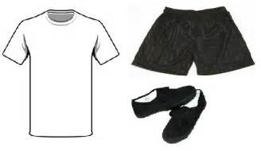 | - Label your child’s clothing – it makes it much easier to return it to the correct owner!  - Speak to staff if they are having difficulty in providing kit. | Have a gym kit to enable them to take part safely in PE. | - Encourage pupils to be as active as possible.  - Understand that these can be difficult times for families and support or sign-post accordingly to a variety of solutions as appropriate ie: clothing grant information, recycled items etc.
This Photo by Unknown Author is licensed under CC BY-SA-NC | - Speak to staff if they are having difficulty in providing snack. | Bring a healthy snack for break time, to help them concentrate until lunch. | - Encourage pupils to be as healthy as possible.  - Provide regular opportunities for hydration.  - Understand that these can be difficult times for families and support or sign-post accordingly to a variety of solutions as appropriate.
This Photo by Unknown Author is licensed under CC BY | - Encourage their child to make lunch choices using the information on the Aberdeen shire website.  - Inform class teachers if children are home lunches, or doing something different from their normal routine. | Know what they are doing and having for lunch. | - Support children to choose a lunch they will enjoy.  - Understand that these can be difficult times for families and support or sign-post accordingly to a variety of solutions as appropriate.
 | - Inform the class teacher if your child is doing something different from their normal home-time routine.  - Advise the school in a timely manner about any changes to collection arrangements at the end of the day. | Know who is collecting them from school which prevents unnecessary distress, worry or upset. | - Contact parents/carers if children are not collected on time.
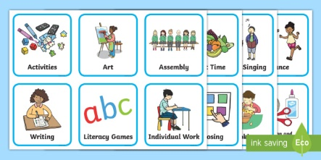 | - Talk to their child/children about the learning they have experienced that day. | Know what they are going to be learning in class each day. | - Share a visual timetable with pupils daily.  - Share Learning Intentions and what Successful learning looks like.  - Inform parents of opportunities for school trips.
Children have adequate sleep.
 | - Ensure children are well rested to be ready to learn during the day. | Be supported to have a night time routine. | - Provide support from health professionals if necessary.
 | - Monitor their child/children’s access to computer games and television, particularly before bedtime.  - The white light from screens means the body is unable to make melatonin, therefore children don’t feel tired.  - It is advised devices are switched off at least an hour before a child goes to bed.  - The impact of playing computer games on learning and behavior is significant. | Be encouraged not to play computer games or watch television before bed. | - Contact parents/carers if they feel sleep is impacting on learning as soon as possible.
Children feel safe at home and in school.
 | - Make time to build relationships and talk to children.  - Check-in regularly to enquire how they are.  - Contact class teachers through the school office if you have any concerns.  - Regularly monitor your child/ren’s online activities to ensure they are accessing safely. | Have someone to talk to in school and at home, who listens to them and responds to their needs. | - Make time to build relationships and talk to children.  - Check-in daily to enquire how they are.  - Share any concerns with parents.
Children are made to feel welcome in school.
 | - Endeavour to have your child arrive at school on time. | Be welcomed to their class each morning. | - Welcome each individual pupil.  - Ensure that even if a child is late they are made to feel welcome.
 | - Support the school’s Climate for Learning Policy. | Observe parents and staff working together to build up positive relationships. | - Spend time listening and talking with children to understand their needs.  - Spend time listening and talking to parents to understand children’s needs.
 | - Seek advice from the school if they have concerns about friendships with other children. | Be supported by staff to build friendships with other children. | - Monitor children in class and the playground and put in appropriate support to ensure children are able to build friendships.
Children have clear boundaries, expectations, consistency and routines at home and in school.
 | - Share consistent behaviour expectations at home and in school.  - Communicate regularly with staff about any concerns.  - Receive support with this by asking school staff. | Know what is expected of them (RAIR) and all adults should remind them of this regularly.  Have consequences which are fair and proportionate. | - Share consistent behaviour expectations (RAIR) at home and in school.  - Communicate regularly with parents about any concerns.  - Receive support with this by seeking advice from SMT.
Children learn in a classroom environment which is stimulating and allows them to meet their full potential with their learning.
 | - Provide pupils with appropriate resources for their age and stage. | Be able to move around the school safely and access all equipment. | - Involve children in the process of managing the classroom.  - Regularly risk assess areas of the school and take action to ensure it is safe.
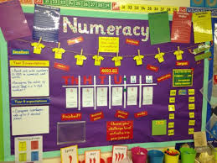 | - Ask their children about what they have learned. | Know how to use wall displays and resources that help them to learn. | - Make sure all displays are relevant to current learning.  - Remind pupils regularly to use wall displays to help their learning.
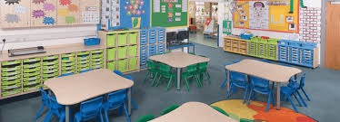 | - Ask their children about strategies they use to learn. | Be able to easily access all resources in the classroom.  Be able to describe how they learn best. | - Label the resources and ensure they are safely accessible.  - Organise resources neatly.  - Provide concrete resources for numeracy work.
Children see parents and school staff working together to support children to learn.
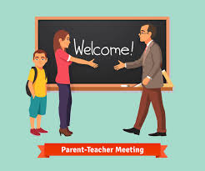 | - Report any absences via the school answering machine/office.  - Communicate areas of difficulty children are having in school at the earliest opportunity.  - Show respect and courtesy in all their interactions with school staff. | Have their learning and development supported at home and school. | - Communicate any areas of difficulty children are having in school at the earliest opportunity.  - Record this information on chronologies and seek advice from SMT.
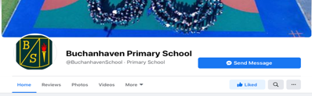 | - Share news of success and achievements (both academic and wider) with school staff.  - Engage with school social media accounts regularly. | Celebrate successes and achievements regularly. | - Make positive phone calls home, gift stickers, house points or certificates.  - Celebrate achievements in assemblies accordingly.  - Use social media to share success and achievement.
 | - Enquire about additional support opportunities as needed. | Be supported to be successful, through access to wider support when necessary. | - Direct parents/carers to the relevant additional support as necessary.

